Test of breast cancer

# Dataset

Dataset “Five types of breast cancer” (<http://www.ihes.fr/~zinovyev/princmanif2006/>) contains 286 instances with 17,816 attributes.

# Direct test

In this section we use our dataset as is. This means that we did not apply any dimensionality reduction procedures. Times for different operation are presented in Table 1

Table 1. Times for separate operations

|  |  |  |
| --- | --- | --- |
| Operation | Time spent (s) | Modified |
| Map initialisation | 9.145649 | 0.711926 |
| drawMap | 0.992934 | 1.064533 |
| Fitting map 'stretch', 0.01, 'bend', 0.1 | 8.641795 |  |
| Fitting map 'stretch', 0.01, 'bend', 1 | 29.448136 |  |
| Fitting map 'stretch', 0, 'bend', 1 continuation | 15.157553 |  |
| Fitting map 'stretch', 0, 'bend', 0.5 continuation | 11.845584 |  |
| Fitting map 'stretch', 0, 'bend', 0.1 continuation | 6.499515 |  |

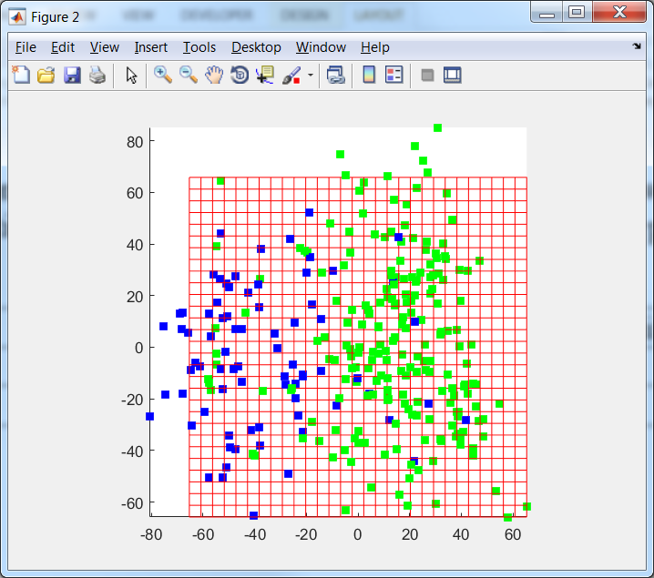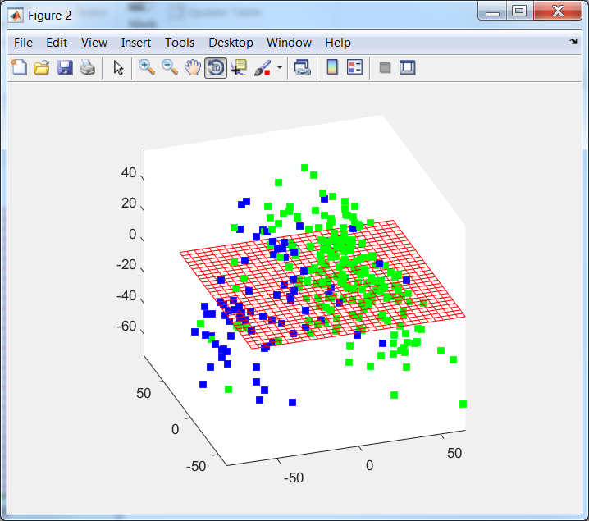

Figure 1. Data points in the space of the first two PCs (left) and first three PCs (right)

For comparison of ElMap and VidaExpert two maps are presented in Figure 2. We can see that map of ElMap is harder and smoother. To obtain the same map as in ViDaExpert we select another modulos. We use continuation of fitting. We can see that the most similar map is the right map in Figure 4.

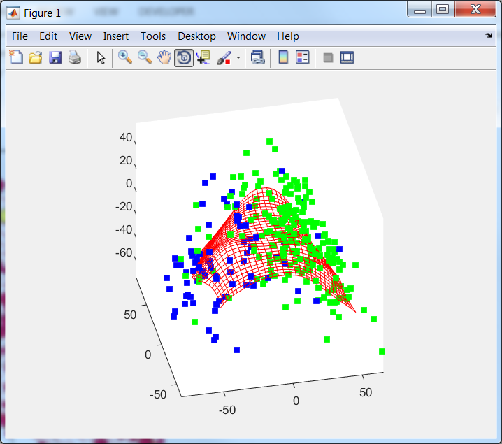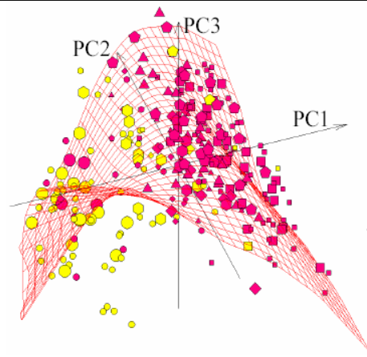

Figure 2. Comparison of ElMap ('stretch', 0.01, 'bend', 0.1) (left) and ViDaExpert maps (right)

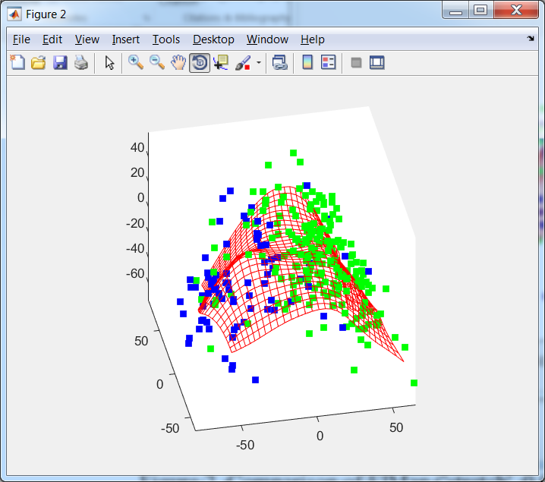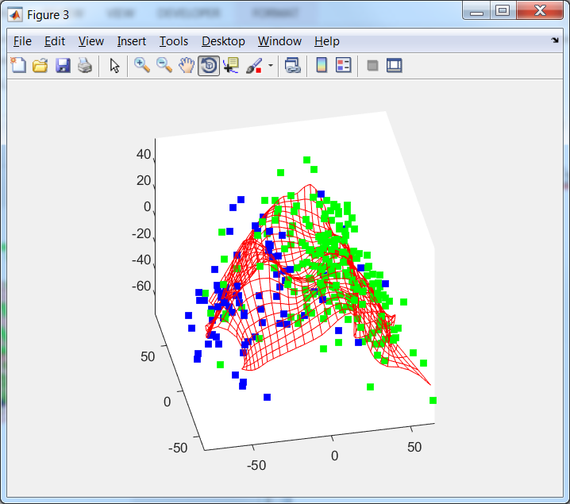

Figure 3. Continuation of fitting ('stretch', 0, 'bend', 0.1); (left) and ('stretch', 0, 'bend', 0.01) (right)

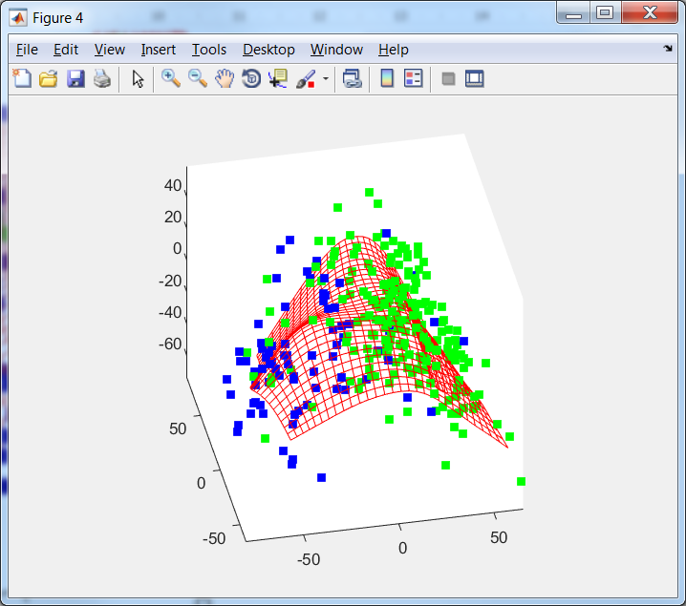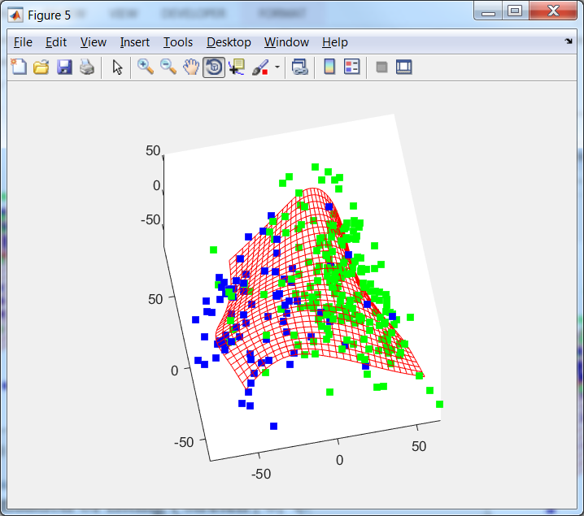

Figure 4. Continuation of fitting ('stretch', 0, 'bend', 0.2); (left) and ('stretch', 0, 'bend', 0.5) (right)

The next experiment is attempt to form map by other trajectory: originally we use stronger parameters and then will soften it. Results are presented in Figure 5.

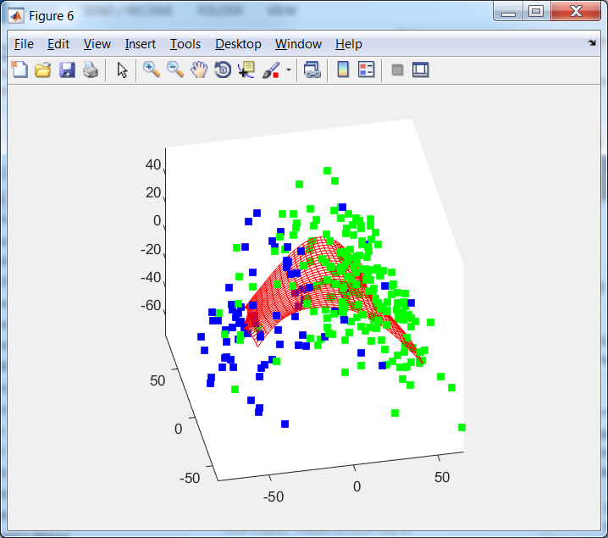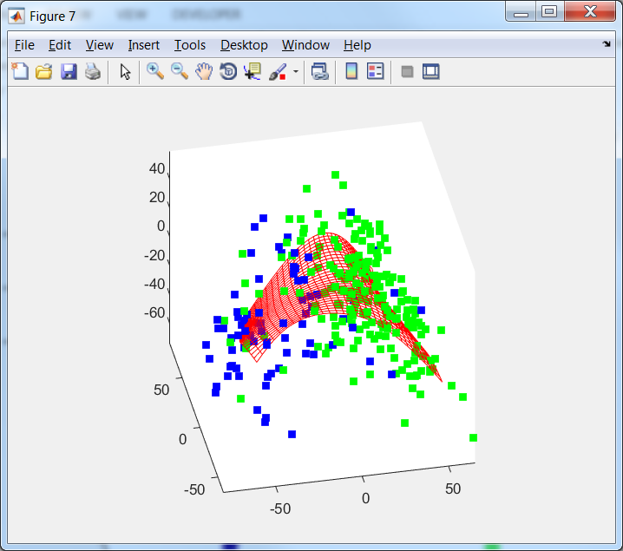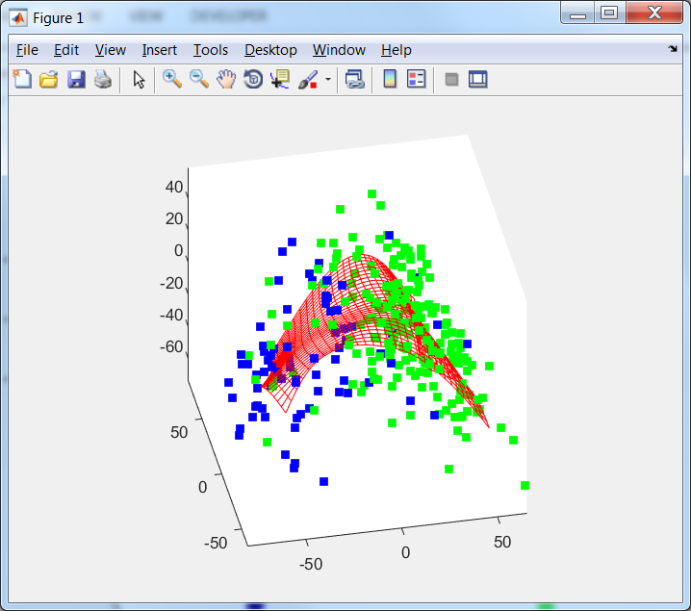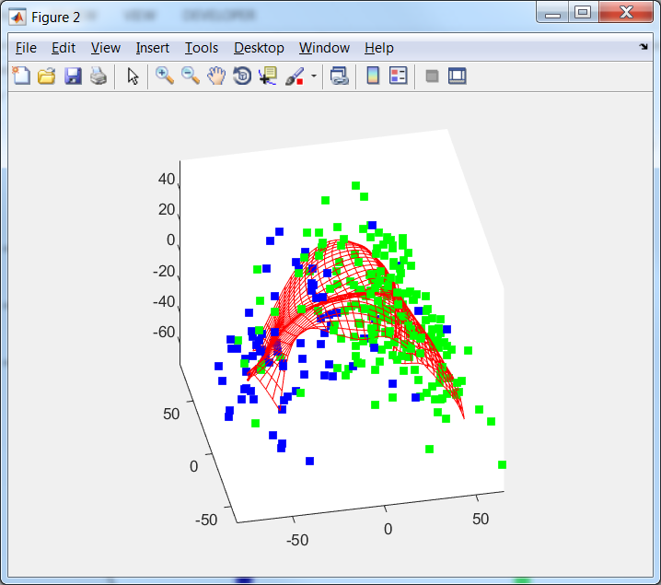

Figure 5. Fitting of ElMap without restart for 'stretch', 0.01, 'bend', 1; 'stretch', 0, 'bend', 1; 'stretch', 0, 'bend', 0.5; 'stretch', 0, 'bend', 0.1

For GitHub

drawMap was modified to customise map node and map edges drawing.

MapGeometry was modified to essentially optimise initialisation.